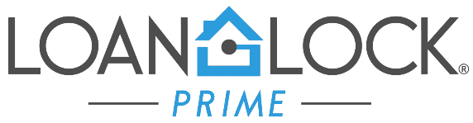
Initial/Early CD Procedure

To process ICD (Initial Closing Disclosure) loan must meet the following eligibility criteria:
☐ Loan must be approved
☐ Appraisal received
☐ Homeowners Insurance received (effective dates must be accurate)
☐ Preliminary Title Report received
☐ Payoffs received (good through funding)
☐ Tax Cert received
☐ Vesting
☐ Settlement Statement with updated loan amount
☐ Lock not expired
☐ Locked LE acknowledged/mailbox delivery
☐ Flood Insurance, if applicable
☐ Condo questionnaire w/invoice, if applicable
☐ Master Policy Evidence of Insurance w/invoice, if applicable
☐ Subordination invoice, if applicable
☐ HOA invoice, if applicable
☐ Pest Inspection w/invoice, if applicable
☐ Non-borrowing title only party contact information (First Name, Last Name, Address, City, State, Zip and email address)
☐ CD/DOC request form

TIPS:
- ALL DOCUMENTS MUST BE SUBMITTED TO CAPITALEND LOAN FILE FOR CD CONSIDERATION. PLEASE REACH OUT TO YOUR ACCOUNT MANAGER TO ENSURE ALL DOCUMENTS HAVE BEEN RECEIVED FOR CD.

- WHILE WE STRIVE TO SEND OUT CDS WITHIN 24 HOURS OF REQUESTS, CD REQUESTS MAY TAKE UP TO 48 HOURS TO SEND OUT.

- BORROWERS INCLUDING NON-BORROWING TITLE ONLY MUST SIGN CD AT LEAST 3 DAYS PRIOR TO CONSUMMATION.

If you have any further questions on obtaining a CD, please reach out to your Account Manager or Account Executive.

